Lab: Design Patterns

Abstract Factory
We are going to create an AbstractFactory class that will have methods for creating chairs, sofas, and tables:
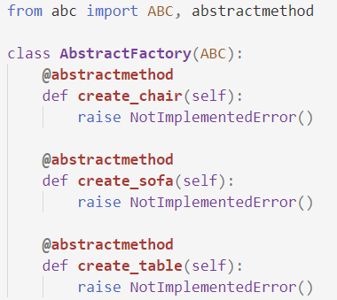
Then we are going to create the Chair, Sofa, and Table classes:
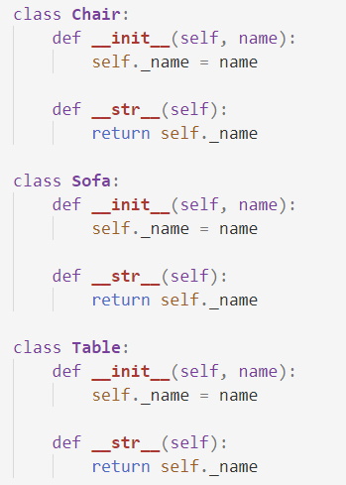

Finally, we are going to create three different factories that will inherit from the AbstractFactiory class: VictorianFactory, ModernFactory, FuturisticFactory
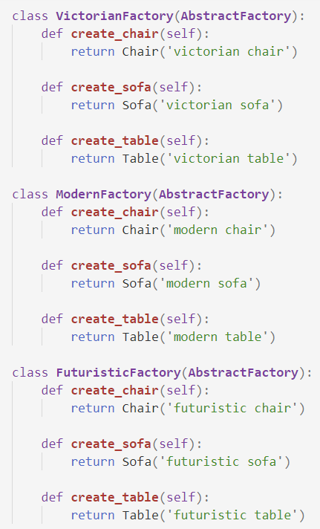

Composite
We are going to create a class called Component which will have move and delete methods:
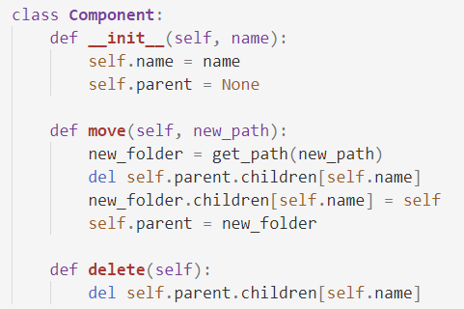
Create two more classes: Folder and File, which inherit from Component. The Folder class should have an add_child method:
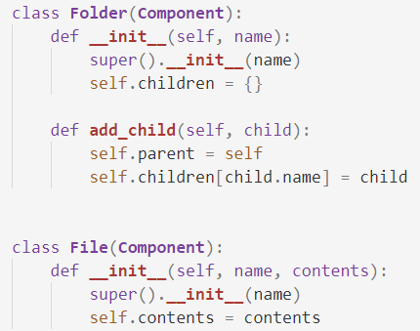
Create a root folder and implement the method get_path:
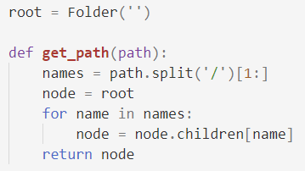

Command
Create a class Window and class Document. The Window class will have an exit method. The Document class will have a save method:
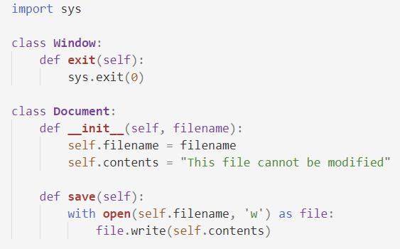
Next, we will create the classes ToolbarDocument, MenuItem, and KeyboardShortcut. The ToolbarDocument and the MenuItem will have a method click. The KeyboardShortcut should have a method called keypress.
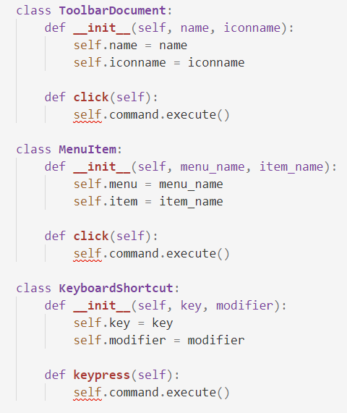
Finally, we will create two command classes SaveCommand and ExitCommand which will have the execute methods implemented in them:
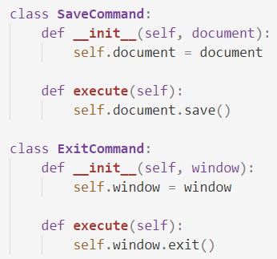

BONUS: File Uploader
Create a simple server (flask) for file uploads of type json and csv. Render a simple HTML form and submit:
- If the format of the file is correct, a message should be displayed in the browser: "File uploaded successfully", and information about the file should be printed on the console
  - CSV Example:
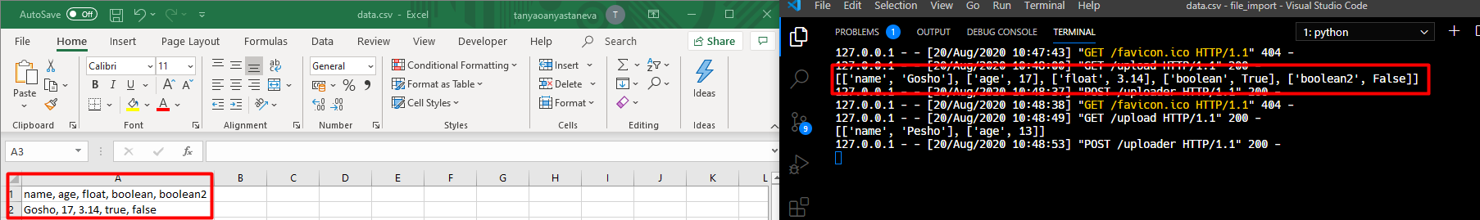
  - JSON Example:
- Otherwise, another message should be displayed: "Invalid content type for import"
Note: Use the design patterns you have learned to build your project

Useful Links
- Flask documentation
- Example solution

